SIMATS ENGINEERING

ASSESSMENT TOOL 2 : Scenario-Based

COURSE NAME: | Cloud Computing and  Big Data Analytics | COURSE CODE: | CSA1514

COURSE OUTCOME COVERED
CO2: Analyze virtualization architectures to identify performance and security issues in cloud computing environments. (BL3)

Dave's Taxonomy: Manipulation (Level 2)  Question Count: 5 | Total Marks: 25

Code of Conduct
I PINDIBOINA SAI DEEPAK (1924111047) certify that this submission is my original work and that I have adhered to the guidelines specified for this assessment.
I understand that any violation of academic integrity rules will result in disciplinary action. Signature of the student: Sai Deepak

Assessment Tasks Scenario-Based Questions

- A media company wants to migrate its video streaming platform to the cloud. The system must handle millions of concurrent users with minimal buffering. Design a cloud architecture using scalability and caching techniques.
Explain how load balancing and auto-scaling can ensure smooth streaming. Discuss cost optimization strategies for such high-demand workloads.

- A fintech startup is deploying applications using containers across multiple cloud providers. They face challenges in maintaining consistency and managing deployments.
Propose a solution using container orchestration and multi-cloud strategies. Explain how service discovery and scaling can be handled efficiently.
Highlight the benefits and risks of a multi-cloud deployment model.

- An e-learning platform experiences data loss due to accidental deletion in the cloud. The organization needs a robust backup and disaster recovery strategy.
Design a solution using cloud-native backup, replication, and versioning.

Explain how recovery time objective (RTO) and recovery point objective (RPO) are achieved. Provide steps to ensure business continuity during failures.

- A government agency is adopting a hybrid cloud model for sensitive and non-sensitive data. Some applications must remain on-premises due to compliance requirements.
Design a hybrid architecture that ensures secure communication between environments. Explain how identity management and encryption should be implemented.
Discuss challenges in managing hybrid cloud environments.
- A SaaS provider needs to ensure high availability and fault tolerance for its application. The system must continue operating even if one region goes down.
Propose a multi-region deployment strategy in the cloud.
Explain how data replication and failover mechanisms should be configured. Discuss monitoring and alerting strategies for proactive issue detection.

Scenario-Based Rubric

Criteria | Weightage | Level 4 - Exemplary | Level 3 - Proficient | Level 2 - Developing | Level 1 - Beginning
Understanding of Scenario | 20% | Demonstrates complete understanding of the scenario  context | Good understanding with minor gaps | Partial understanding | Fails to understand the scenario
Identification of Risks / Issues | 20% | Identifies all major issues correctly | Identifies most issues | Limited issue identification | Misses major issues
Application of Concepts | 25% | Applies virtualization concepts  effectively | Applies concepts with minor mistakes | Partially correct application | Weak application
Decision Justification | 20% | Decisions are well justified and technically strong | Reasonable justification | Weak justification | No useful justification
Clarity | 15% | Clear and  well-organized response | Generally clear | Somewhat unclear | Poorly presented

SET 2:

1.A retail company collects terabytes of customer transaction data every day from online and offline stores. The management wants to analyze purchasing patterns in near real time to improve product
recommendations and inventory management.

- Design a cloud-based big data architecture using distributed storage and processing frameworks.
- Explain how batch processing and stream processing can be integrated.
- Discuss how data lakes and data warehouses can be used together.
- Recommend techniques to ensure scalability and cost efficiency.

2.A healthcare organization is migrating patient records and medical imaging data to the cloud. The solution must comply with strict privacy regulations while allowing authorized doctors to access records securely from multiple locations.
- Design a secure cloud architecture that protects sensitive healthcare data.
- Explain how encryption, identity and access management (IAM), and key management should be implemented.
- Discuss auditing, logging, and compliance monitoring strategies.
- Recommend methods to prevent unauthorized access and data breaches.

- An online ticket booking platform experiences sudden spikes in traffic whenever popular events are announced. The company wants to reduce infrastructure management while ensuring fast response times.
  - Design a serverless cloud architecture for the application.
  - Explain how event-driven computing can improve scalability.
  - Discuss the role of managed databases, API gateways, and message queues.
  - Evaluate the advantages and limitations of serverless computing for this workload.

- A multinational company gathers data from sales, finance, manufacturing, and customer support systems. The organization requires a centralized analytics platform with high-quality and consistent data.
  - Design a cloud-based ETL/ELT pipeline for integrating data from multiple sources.
  - Explain how data quality, metadata management, and governance should be maintained.
  - Discuss the role of workflow orchestration and scheduling tools.
  - Recommend strategies for optimizing query performance and storage costs.

- A logistics company wants to predict delivery delays using historical shipment data, weather information, and live GPS tracking. The analytics platform must support continuous model training and real-time predictions.
  - Design a cloud-based machine learning and analytics architecture.
  - Explain how big data technologies can support model training and inference.
  - Discuss the use of cloud-native AI/ML services for model deployment and monitoring.
  - Recommend strategies for handling large-scale data ingestion, feature engineering, and model updates.

1. Retail Company: Real-Time Big Data Analytics Architecture
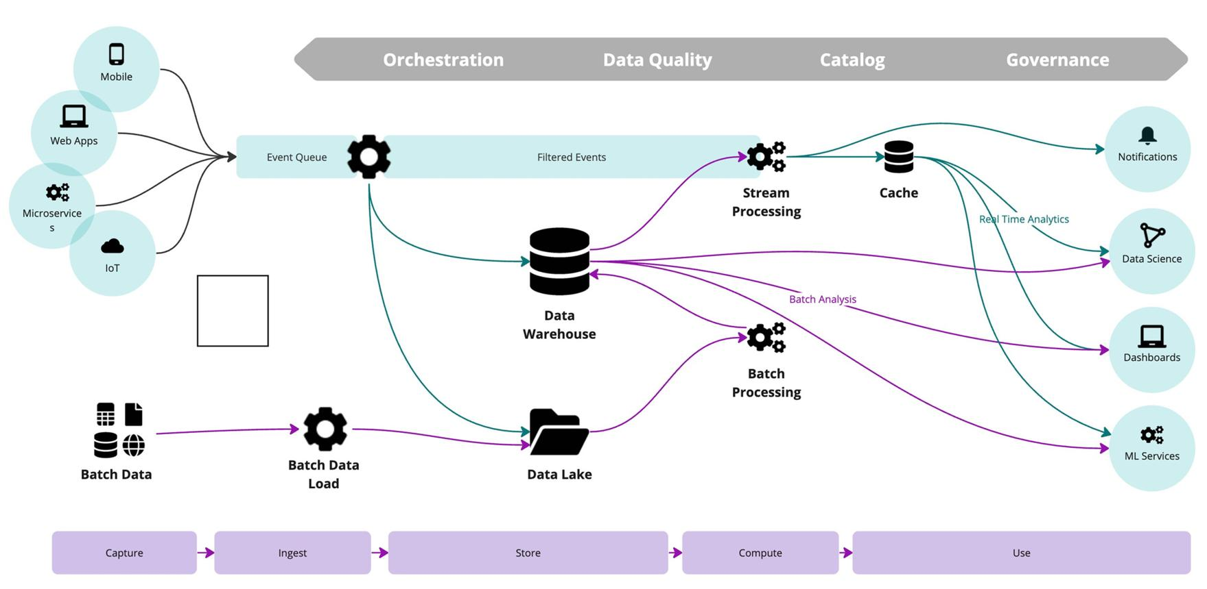
Architecture design:
The retail company can use a cloud-based big data architecture that combines distributed storage, batch processing, and stream processing.
The proposed architecture consists of:
- Data Sources: Collect transaction data from online shopping websites, mobile applications, billing systems, and physical retail stores.
- Data Ingestion: Use Apache Kafka or Amazon Kinesis to collect and transfer large volumes of transaction data.
- Distributed Storage: Store raw data in Amazon S3, Azure Data Lake Storage, or Google Cloud Storage. These systems provide scalable storage.
- Data Processing: Use Apache Spark for large-scale batch processing and Apache Flink or Spark Structured Streaming for real-time processing.
- Analytics: Use cloud data warehouses such as Amazon Redshift, Google BigQuery, or Snowflake to analyze processed data.
- Visualization: Use Power BI, Tableau, or Amazon QuickSight to display sales trends, customer behavior, and inventory information.
Integration of Batch Processing and Stream Processing:
- Batch processing: Processes large amounts of historical transaction data at scheduled intervals. Apache Spark can identify monthly sales trends, popular products, and customer purchasing patterns.
- Stream processing: Processes incoming transactions continuously. Kafka and Apache Flink can identify current demand and update product recommendations immediately.
- Both approaches can share the same storage and analytics platform to provide historical and real-time insights.
Use of Data Lakes and Data Warehouses:
- Data Lake: Stores large volumes of raw structured, semi-structured, and unstructured data. It supports flexible analysis and future processing.
- Data Warehouse: Stores cleaned, transformed, and organized data. It is used for business reporting, dashboards, and SQL-based analysis.
- The data lake acts as the central storage system, while the warehouse provides reliable data for business decisions.
Scalability and Cost Efficiency:
- Use distributed storage and processing to handle increasing transaction volumes.
- Implement auto-scaling to increase or decrease computing resources based on workload.
- Use serverless processing where suitable to avoid maintaining idle servers.
- Apply data compression and columnar formats such as Parquet.
- Move older, less frequently accessed data to low-cost archival storage.
- Monitor cloud resource usage and apply budget limits.
Result: The proposed architecture helps the retail company analyze customer purchasing patterns in near real time, improve product recommendations, and maintain optimal inventory levels.
2. Healthcare Organization: Secure Cloud Architecture
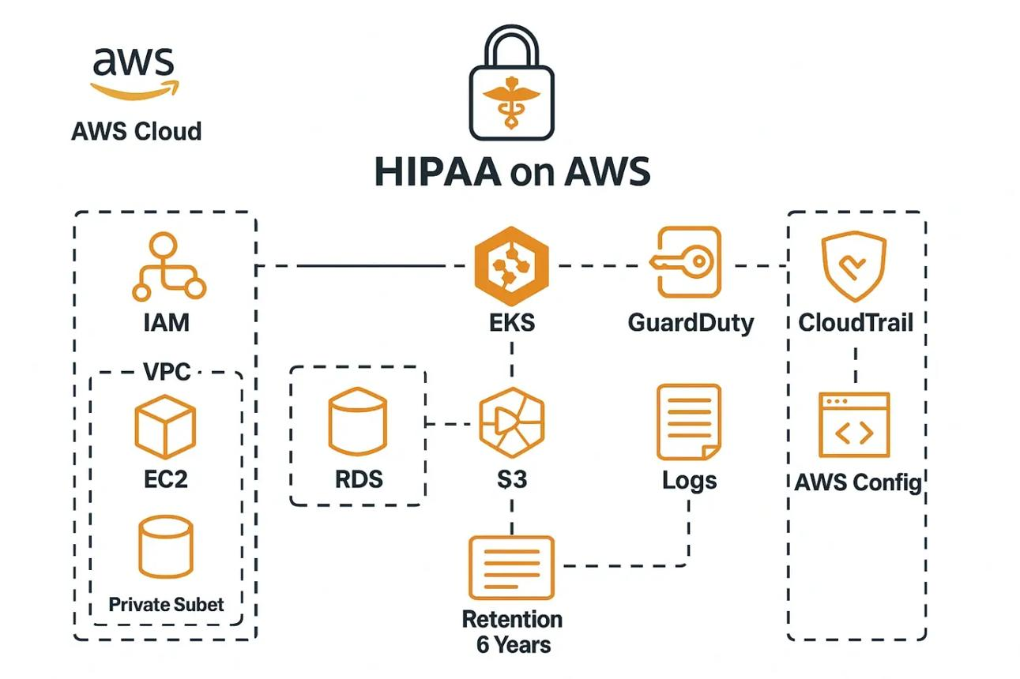
ezyinfra.dev
Architecture design:
The healthcare organization should adopt a secure cloud architecture that protects electronic health records (EHR), patient details, and medical imaging data.
The proposed architecture includes:
- Data Sources: Patient records, hospital management systems, laboratory reports, and medical imaging devices.
- Secure Data Transfer: Use HTTPS with TLS encryption and private network connections to transfer patient information securely.
- Cloud Storage: Store patient records in encrypted databases and medical images in secure object storage.
- Application Layer: Deploy healthcare applications using private cloud networks and controlled application services.
- Access Management: Use Identity and Access Management (IAM) to ensure that only authorized doctors and healthcare employees can access patient records.
- Monitoring: Implement centralized logging, auditing, and security monitoring.
Implementation of Encryption, IAM, and Key Management:
- Encryption at Rest: Use AES-256 encryption to protect stored patient records and medical images.
- Encryption in Transit: Use HTTPS and TLS to protect information transferred between doctors, applications, and cloud servers.
- Identity and Access Management: Implement role-based access control (RBAC). Doctors can access assigned patient records, while administrators receive only the permissions required for their duties.
- Multi-Factor Authentication (MFA): Require additional verification during login to prevent unauthorized access.
- Key Management: Use services such as AWS Key Management Service (KMS) or Azure Key Vault to securely generate, store, rotate, and manage encryption keys.
Auditing, Logging, and Compliance Monitoring:
- Maintain audit logs of user logins, patient record access, data modifications, and downloads.
- Use AWS CloudTrail or Azure Monitor to track cloud activities.
- Set alerts for unusual login attempts and unauthorized access.
- Conduct regular security assessments and compliance audits.
- Follow applicable regulations such as India's Digital Personal Data Protection Act (DPDP Act), along with relevant healthcare and data protection requirements.
Methods to Prevent Unauthorized Access and Data Breaches:
- Apply least-privilege access permissions.
- Enable MFA for all authorized users.
- Use firewalls and network segmentation.
- Perform regular vulnerability assessments and security updates.
- Maintain encrypted backups and disaster recovery systems.
- Use intrusion detection and threat monitoring tools.
Result: The secure cloud architecture protects sensitive patient information while allowing authorized doctors to access medical records from different locations without compromising data privacy.
3. Online Ticket Booking: Serverless Cloud Architecture
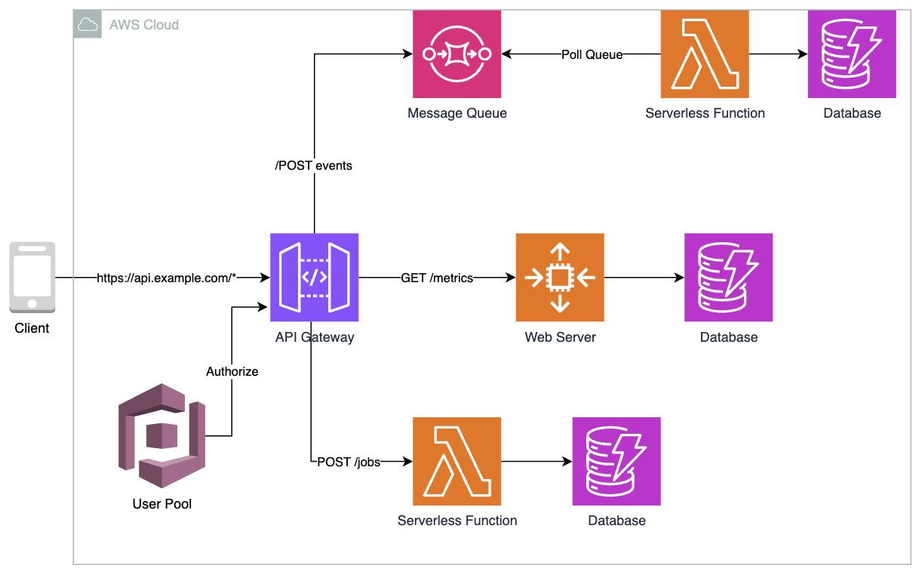
Architecture design:
The ticket booking platform can use serverless computing to handle sudden traffic increases during popular event announcements. Serverless architecture eliminates the need to manage physical servers or continuously running virtual machines.
The proposed architecture includes:
- Frontend: Develop the website and mobile application and host static content using Amazon S3 or Azure Static Web Apps.
- Content Delivery Network: Use Amazon CloudFront to deliver application content quickly to users from nearby locations.
- API Gateway: Use Amazon API Gateway to receive and manage requests from users.
- Serverless Computing: Use AWS Lambda or Azure Functions to execute booking, payment, cancellation, and ticket generation functions.
- Message Queue: Use Amazon SQS or Azure Queue Storage to manage booking requests and process tasks asynchronously.
- Managed Database: Use Amazon DynamoDB or Amazon Aurora Serverless to store customer details, event information, and booking records.
Role of Event-Driven Computing:
- Event-driven computing executes functions when specific events occur.
- When a user books a ticket, an event triggers a serverless function.
- The function checks ticket availability and processes the booking.
- A message queue handles background tasks such as sending confirmation emails and generating tickets.
- Serverless functions automatically scale based on incoming requests.
This architecture handles sudden traffic spikes without requiring manual server management.
Role of Managed Databases, API Gateways, and Message Queues:
- Managed Databases: Store ticket availability, customer details, and booking information without requiring manual database infrastructure management.
- API Gateway: Provides a single entry point for application requests, authentication, rate limiting, and request routing.
- Message Queues: Temporarily store requests and distribute them to processing functions. They prevent backend systems from becoming overloaded.
- Caching: Use Amazon ElastiCache or a suitable caching service to reduce repeated database queries for event information.
For ticket booking, database transactions and atomic inventory updates are essential to prevent two users from purchasing the same seat.
Advantages and Limitations of Serverless Computing:
Advantages:
- Automatically scales according to incoming traffic.
- Reduces server maintenance and infrastructure management.
- Charges are generally based on actual resource consumption.
- Supports event-driven application development.
- Provides integration with managed databases and cloud services.
Limitations:
- Cold starts may increase response time for inactive functions.
- Execution time and resource limits may affect long-running tasks.
- Heavy workloads can create unpredictable costs.
- Vendor lock-in may occur when using provider-specific services.
- Distributed functions can make debugging more difficult.
Result: Serverless computing enables the ticket booking platform to handle sudden increases in user traffic, reduce infrastructure management, and provide faster booking services.
4. Multinational Company: Cloud-Based ETL/ELT Pipeline
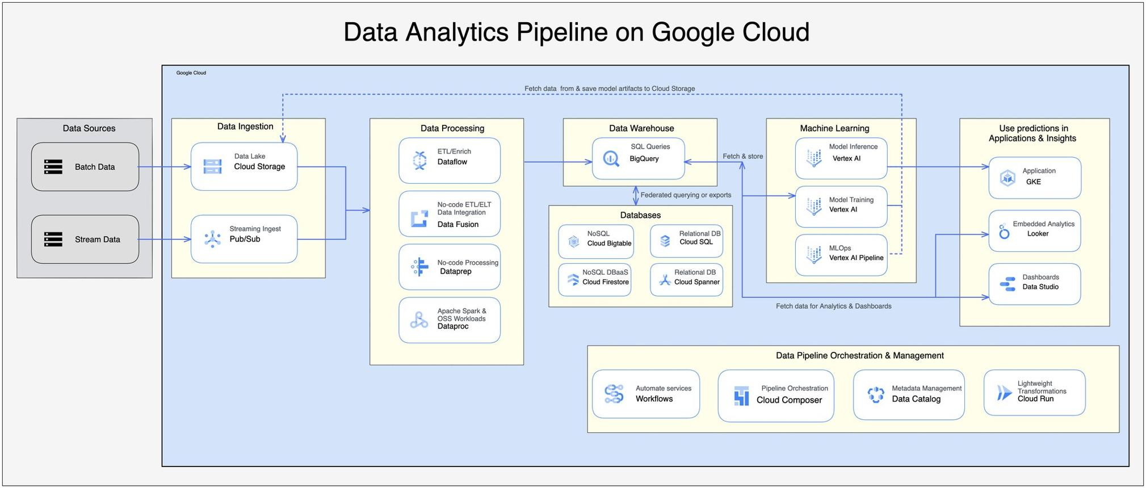
Architecture design:
The multinational company should implement a centralized cloud-based ETL/ELT pipeline to integrate data from sales, finance, manufacturing, and customer support systems.
The proposed architecture consists of:
- Data Sources: Collect information from ERP, CRM, financial databases, manufacturing applications, and customer support systems.
- Data Extraction: Use Apache NiFi, AWS Glue, or Azure Data Factory to extract information from different sources.
- Data Storage: Store raw data in a centralized cloud data lake such as Amazon S3 or Azure Data Lake Storage.
- Data Transformation: Use Apache Spark, AWS Glue, or cloud-native SQL engines to clean, validate, and transform data.
- Data Warehouse: Load the processed information into Amazon Redshift, Google BigQuery, or Snowflake.
- Analytics: Connect Power BI or Tableau to generate centralized business reports and interactive dashboards.
Data Quality, Metadata Management, and Governance:
- Data Quality: Remove duplicate records, handle missing values, validate data types, and maintain consistent formats.
- Metadata Management: Maintain information about data sources, formats, ownership, relationships, and update frequency.
- Data Governance: Establish policies for data access, security, ownership, retention, and usage.
- Data Catalog: Use AWS Glue Data Catalog or Microsoft Purview to organize and discover available datasets.
- Data Validation: Apply validation rules to identify incorrect or incomplete information before loading it into the warehouse.
Role of Workflow Orchestration and Scheduling Tools:
- Use Apache Airflow, AWS Step Functions, or Azure Data Factory pipelines to coordinate data processing activities.
- Schedule daily, hourly, or real-time data integration jobs.
- Define dependencies between extraction, transformation, and loading tasks.
- Automatically retry failed tasks.
- Generate alerts when data pipelines fail.
- Maintain execution logs to monitor pipeline performance.
Query Performance and Storage Cost Optimization:
- Use partitioning to divide large datasets based on date, region, or business category.
- Apply indexing and appropriate clustering techniques where supported.
- Store data in compressed columnar formats such as Parquet.
- Use materialized views for frequently executed queries.
- Archive historical data that is not frequently accessed.
- Apply lifecycle policies to move older data into cheaper storage tiers.
- Use workload management and query monitoring to prevent unnecessary resource consumption.
Result: The centralized ETL/ELT architecture provides consistent, reliable, and high-quality business data, enabling the multinational company to make informed decisions across all departments.
5. Logistics Company: Cloud-Based Machine Learning and Analytics Architecture
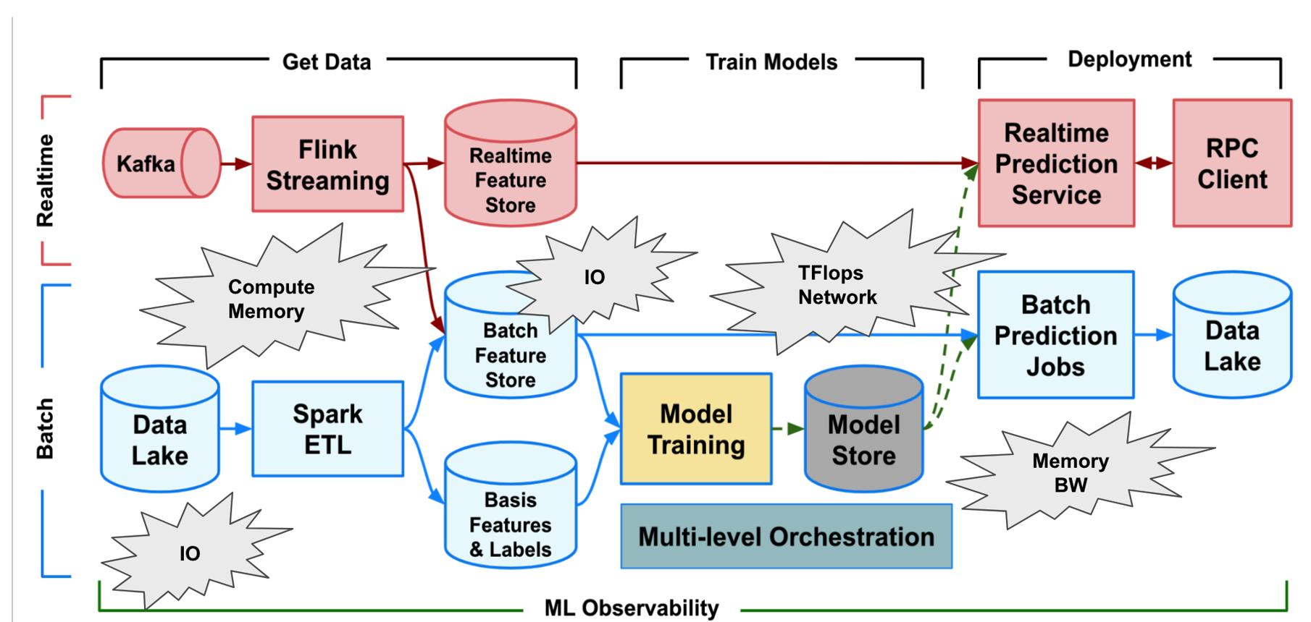

Architecture design:
The logistics company can implement a cloud-based machine learning architecture to predict delivery delays using historical shipment records, weather information, and live GPS tracking data.
The proposed architecture consists of:
- Data Sources: Collect historical shipment information, GPS coordinates, weather conditions, traffic data, and vehicle information.
- Data Ingestion: Use Apache Kafka, Amazon Kinesis, or Azure Event Hubs to collect continuous GPS and weather data.
- Cloud Storage: Store historical and incoming data in Amazon S3, Azure Data Lake Storage, or Google Cloud Storage.
- Data Processing: Use Apache Spark or Databricks to clean, process, and combine large datasets.
- Feature Engineering: Extract useful features such as distance travelled, traffic conditions, average speed, weather conditions, and estimated delivery time.
- Model Training: Use Amazon SageMaker, Azure Machine Learning, or Google Vertex AI to train machine learning models.
- Model Deployment: Deploy the trained model as a cloud endpoint to provide real-time delivery delay predictions.
- Visualization: Use Power BI or Tableau to display delivery status, predicted delays, and logistics performance.
Role of Big Data Technologies in Model Training and Inference:
- Apache Spark processes large historical shipment datasets efficiently using distributed computing.
- Apache Kafka collects continuous GPS and weather information.
- Distributed storage systems maintain large historical datasets.
- Machine learning algorithms such as Random Forest, XGBoost, and Gradient Boosting can predict delivery delays.
- Real-time inference services use incoming shipment information to generate immediate predictions.
For example, if a vehicle is travelling through heavy traffic during bad weather, the model can analyze these conditions and predict a possible delivery delay.
Cloud-Native AI/ML Services for Deployment and Monitoring:
- Amazon SageMaker: Supports model training, deployment, and monitoring.
- Azure Machine Learning: Provides model development, deployment, and lifecycle management.
- Google Vertex AI: Supports machine learning training, prediction, and model monitoring.
- Model Monitoring: Track prediction accuracy, data drift, and model performance.
- Automated Retraining: Retrain models periodically when new shipment data becomes available.
Strategies for Data Ingestion, Feature Engineering, and Model Updates:
- Use Kafka or Kinesis to handle high-volume real-time data ingestion.
- Apply distributed processing using Apache Spark.
- Remove duplicate and incorrect GPS records.
- Handle missing weather and shipment values.
- Create useful features such as traffic density, delivery distance, and average vehicle speed.
- Store frequently used features in a feature store.
- Use automated ML pipelines to retrain models with updated historical data.
- Monitor model accuracy and deploy updated models using controlled rollout strategies.
Result: The proposed machine learning architecture helps the logistics company predict delivery delays, improve route planning, optimize delivery operations, and provide better customer service.

